Ideation Phase
Define the Problem Statements

Date | 15 February 2026
Team ID | LTVIP2026TMIDS24941
Project Name | ToyCraft Tales: Tableau's Vision into Toy  Manufacturer Data
Maximum Marks | 2 Marks

Customer Problem Statement Template:
Create a problem statement to understand your customer's point of view. The Customer Problem Statement template helps you focus on what matters to create experiences people will love.
A well-articulated customer problem statement allows you and your team to find the ideal solution for the challenges your customers face. Throughout the process, you’ll also be able to empathize with your customers, which helps you better understand how they perceive your product or service.
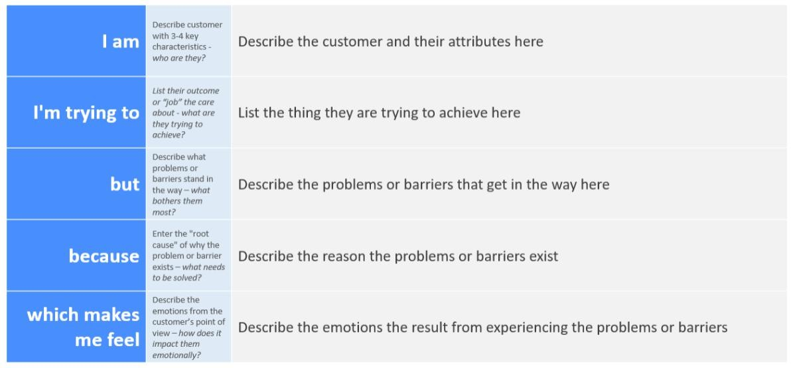
Reference: https://miro.com/templates/customer-problem-statement/
Example:
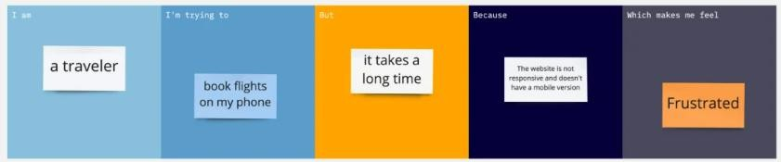

PS-1:

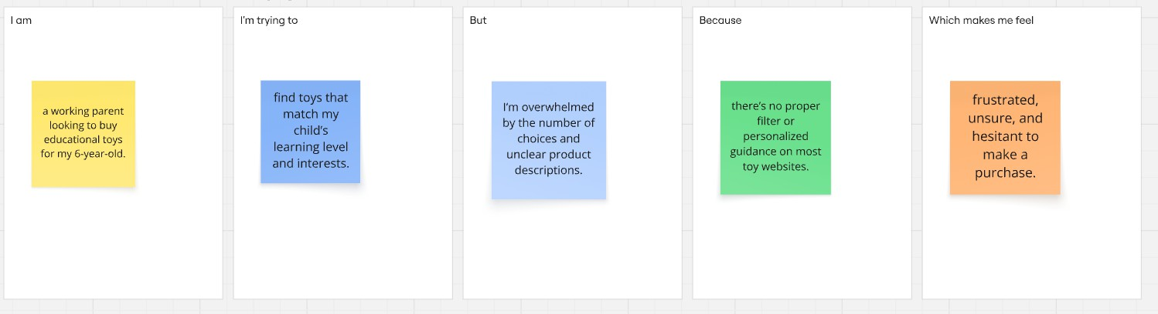
PS-2:
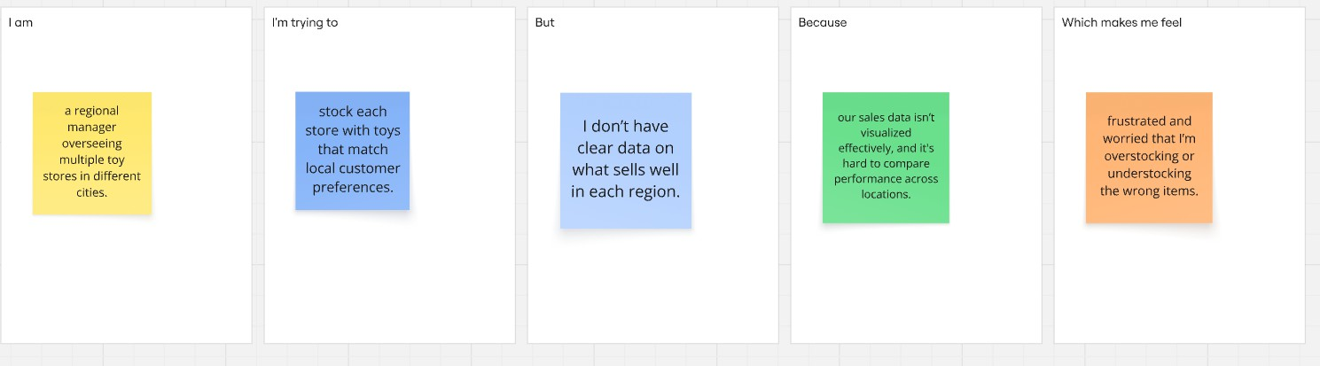

Problem Statement (PS) | I am (Customer) | I’m trying to | But | Because | Which makes me feel
PS-1 | a working parent looking to buy educational toys for my 6-year-old. | find toys that match my child’s learning level and interests. | I’m overwhelm ed by the number of choices and unclear product descriptions  . | there’s no proper filter or personalized guidance on most toy websites. | frustrated, unsure, and hesitant to make a purchase.
PS-2 | a regional manager overseeing multiple toy stores in different cities. | stock each store with toys that match local customer preferences. | I don’t have clear data on what sells well in each region. | our sales data isn’t visualized effectively,  and it's hard to compare performance across locations. | frustrated and worried that I’m overstocking or  understocking the wrong items.

